**Viewer Sentiment Analysis - Entertainment Sector**

Pooja Joshi & E.Code [E25007]

# Overview :

# The Viewer Sentiment Analysis project aims to analyze the sentiment of viewers towards different movies in the entertainment sector. By examining the relationships between sentiment, valuation, attendance, and other metrics, the analysis provides insights into audience perceptions and preferences.

# Objective:

· To analyze viewer sentiments and their correlation with movie valuation and attendance.

· To identify trends and patterns in sentiment based on genres and other relevant factors.

· To propose recommendations for improving audience engagement and satisfaction.

# Assigned Task(s) :

· Analyze the correlation between valuation and attendance count for each sentiment group.

· Explore sentiment distribution by genre.

· Conduct a time-based analysis of sentiment evolution over release years.

· Perform sentiment analysis on viewer reviews using NLP techniques.

# Task Details :

**Task 1: Correlation Analysis**

* **Status:** Completed
* **Details:** Analyzed the correlation between movie valuation and attendance count across different sentiment groups (Positive, Neutral, Negative). Scatter plots were generated to visualize the relationships.

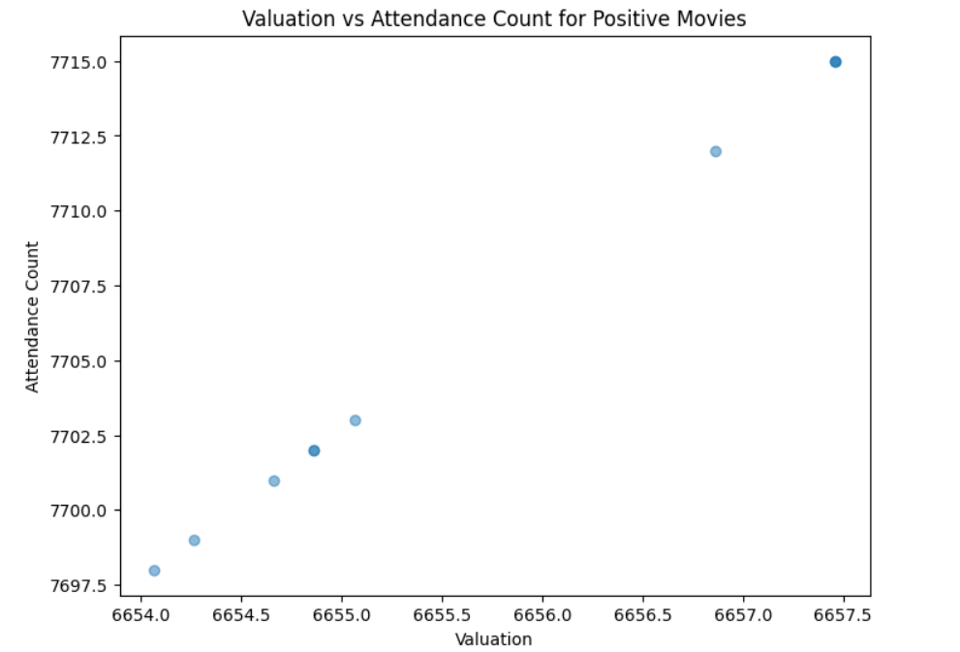

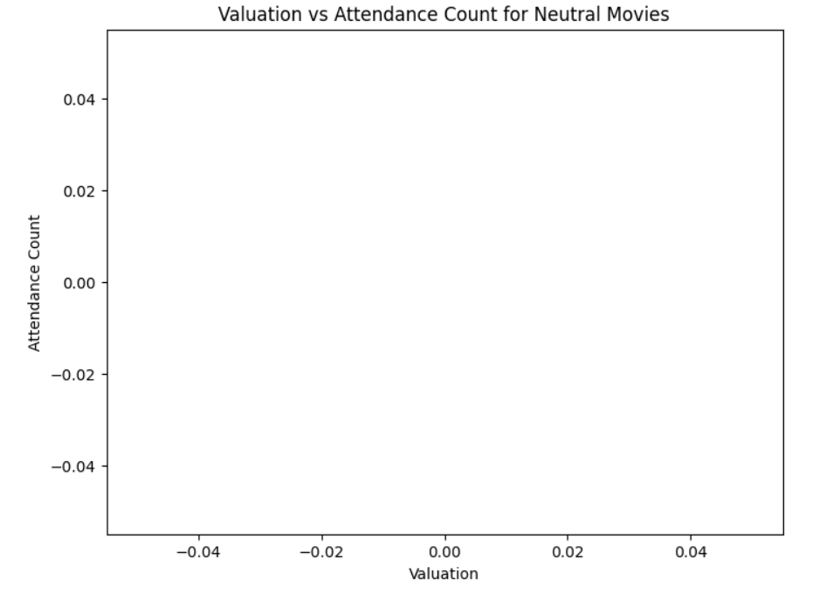

**Task 2: Sentiment Distribution Analysis**

* **Status:** Completed
* **Details:** Conducted a sentiment distribution analysis based on available sentiment ratings. The results were visualized using bar charts.

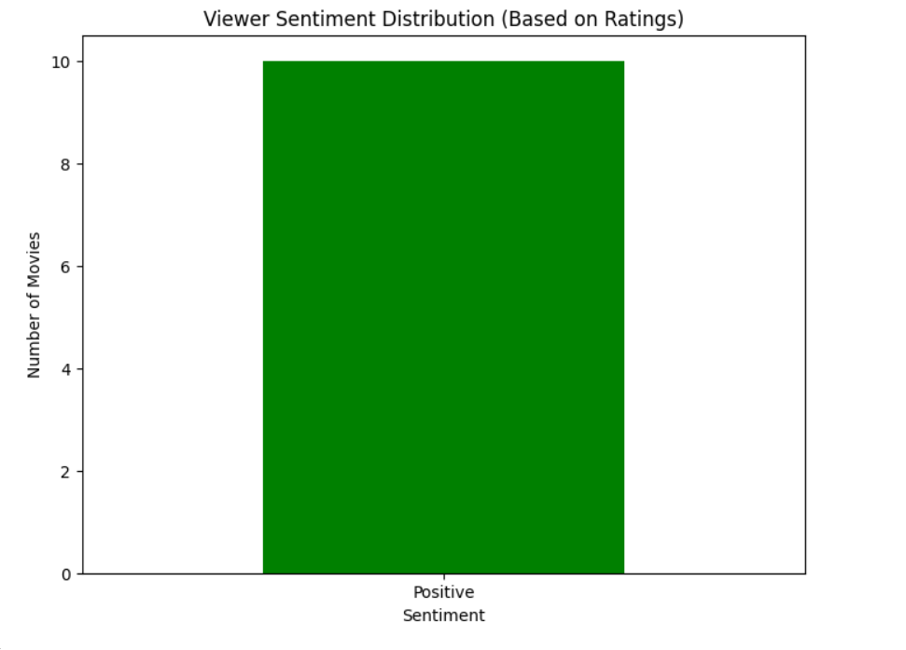

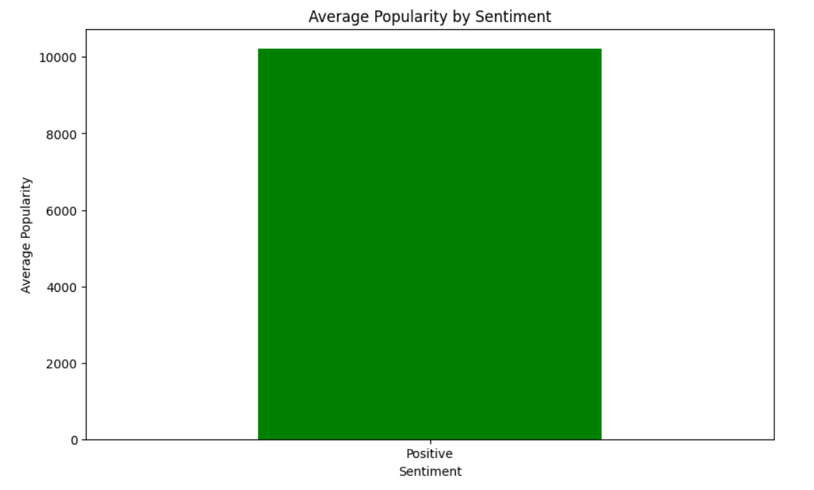

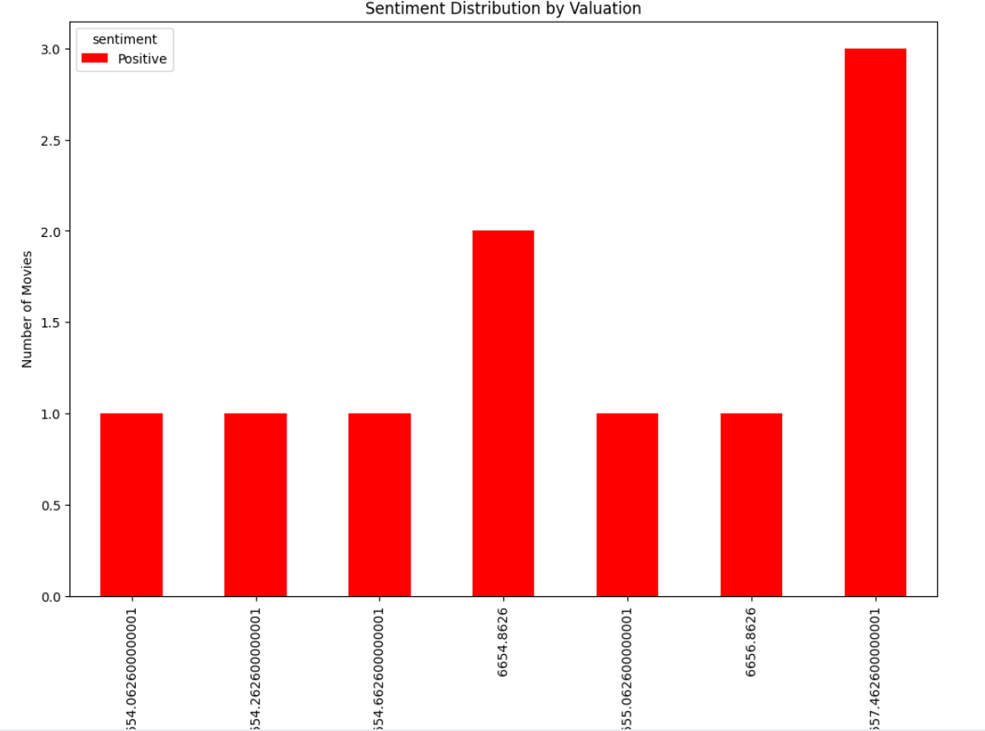

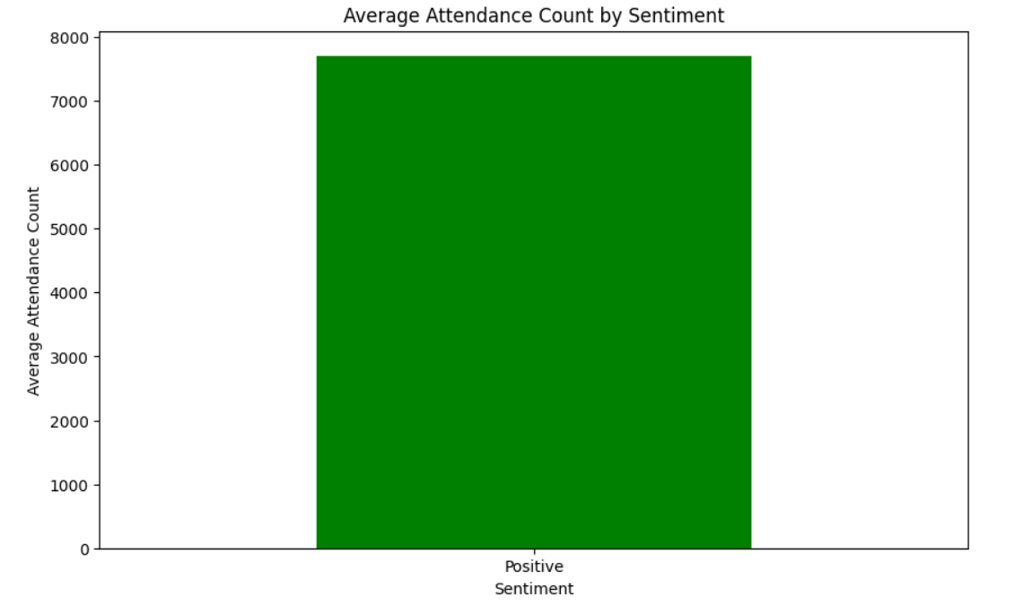

**Task 3: Time-Based Sentiment Analysis**

* **Status:** Completed
* **Details:** Aim to utilize release dates (if available) to observe how viewer sentiment evolves over time.

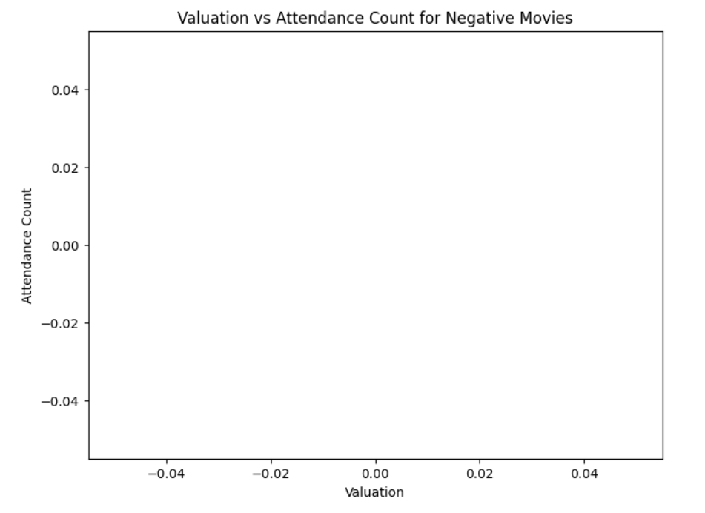

**Task 4: NLP Sentiment Analysis**

* **Status:** Completed
* **Details:** Implemented NLP techniques to analyze text reviews, categorizing them into Positive, Neutral, and Negative sentiments. A bar chart visualized the distribution of sentiments based on the reviews.

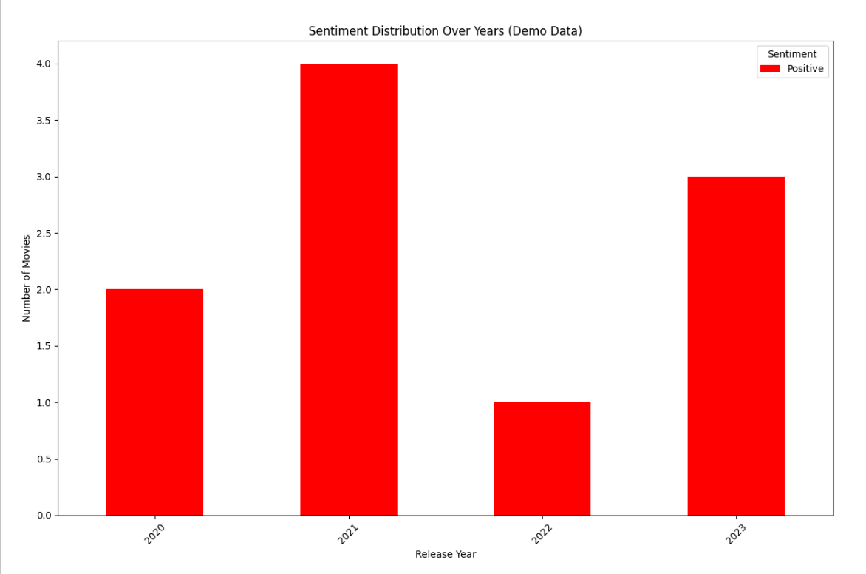

**Progress :**

· **Accomplishments:** Completed correlation analysis and NLP sentiment analysis tasks. Successfully created a demo release date column for time-based analysis.

·

**Metrics:**

* Correlation values between valuation and attendance count for different sentiments were calculated.
* Average sentiment scores over the years will be visualized in the upcoming analysis.

# Challenges and Solutions :

· **Challenges Faced:** The main challenge was the lack of a release date column in the dataset.

· **Solutions Implemented:** A demo release date column was created to facilitate the time-based sentiment analysis.

# Next Steps :

#### ****Upcoming Tasks:****

· **Upcoming Tasks:** Complete the time-based sentiment analysis and visualize the average sentiment over time.

· **Goals:** Analyze the output of the time-based sentiment analysis and present findings on trends in viewer sentiment over the years.

# Conclusion :

# Summary: In summary, the viewer sentiment analysis has made significant progress, with successful completion of correlation and NLP tasks. The time-based analysis is underway, aiming to provide insights into how viewer sentiment changes over time.

# **Acknowledgments**: Thank the audience for their time and attention.

# Instructions:

1. Use Google Docs. Single Column
2. TNR stands for Times New Roman: B - Bold
3. Use images as required with proper references
4. Use charts, tables as per your requirement.
5. Number of Pages: 2 to 8 for each task report.